Homework 3

Adam Phung

1) Using OpenGL draw a 2D geometric figure, either by using lines or polygons and implement the following transformations:

**a) Draw coordinate axes in different colors.**

// Draw axis

drawLineGL(0, -1000, 0, 1000, 1, 1.0f, 1.0f, 0.0f);

drawLineGL(-1000, 0, 1000, 0, 1, 1.0f, 1.0f, 0.0f);

double shapeX[8] = {-50, 25, 25, 50, 25, 25, -50, -40};

double shapeY[8] = {15, 15, 30, 0, -30, -15, -15, 0};

double Xn[8] = {0, 0, 0, 0, 0, 0, 0, 0};

double Yn[8] = {0, 0, 0, 0, 0, 0, 0, 0};

// Draw Arrow

drawShape(shapeX, shapeY, 8, 3);

void drawShape(double *x, double *y, int count, int width) {

// Enable anti-aliasing

glEnable(GL_LINE_SMOOTH);

glHint(GL_LINE_SMOOTH_HINT, GL_NICEST);

glEnable(GL_BLEND);

glBlendFunc(GL_SRC_ALPHA, GL_ONE_MINUS_SRC_ALPHA);

// Draw

glLineWidth(width); // Line Width

glBegin(GL_LINE_LOOP); // Draw Line (GL_LINE_LOOP)

glColor3f(0.0f, 1.0f, 0.0f);

for (int i = 0; i < count; i++) {

glVertex2i(x[i], y[i]);

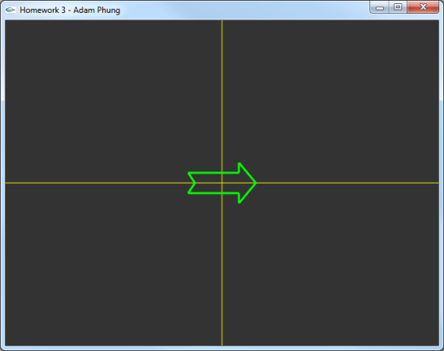 }

glEnd();

glDisable(GL_BLEND);

}

**b) translate your figure along y axis for 1,5 times the figure's y size.**

double a = 1.0;

double b = 0.0;

double c = 0.0;

double d = 1.0;

int tx = 0;

int ty = 0;

/// Problem b: translate your figure along y axis for 1,5 times the figure's y size.

int size = 100;

ty = size;

for (int i = 0; i < 8; i++) {

Xn[i] = a*shapeX[i] + b*shapeY[i]+tx;

Yn[i] = c*shapeX[i] + d*shapeY[i]+ty;

}

drawShape(Xn, Yn, 8, 3);

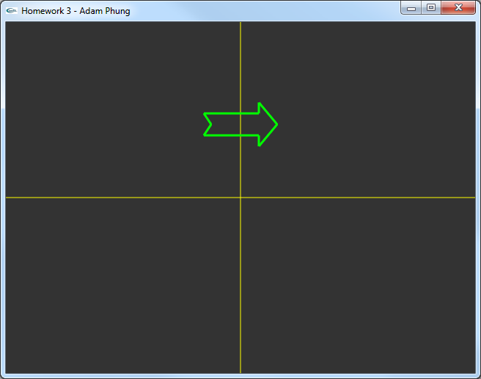

**c) rotate your figure clockwise for 30 degrees.**

/// Problem c: rotate your figure clockwise for 30 degrees.

double angle = -0.3f;

a = cos(angle);

b = -sin(angle);

c = sin(angle);

d = cos(angle);

tx = 0;

ty = 0;

for (int i = 0; i < 8; i++) {

Xn[i] = a*shapeX[i] + b*shapeY[i]+tx;

Yn[i] = c*shapeX[i] + d*shapeY[i]+ty;

}

drawShape(Xn, Yn, 8, 3);

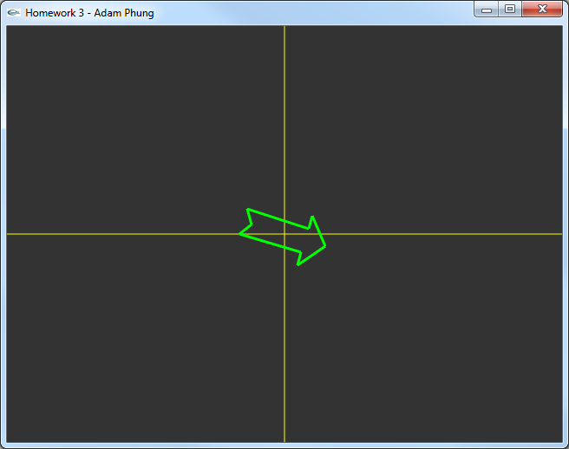

**d) scale the y dimension of your figure for 0.75.**

/// Problem d: scale the y dimension of your figure for 0.75.

angle = 0.0f;

double scale = 0.75;

a = cos(angle);

b = -sin(angle);

c = sin(angle);

d = cos(angle) + scale;

tx = 0;

ty = 0;

for (int i = 0; i < 8; i++) {

Xn[i] = a*shapeX[i] + b*shapeY[i]+tx;

Yn[i] = c*shapeX[i] + d*shapeY[i]+ty;

}

drawShape(Xn, Yn, 8, 3);

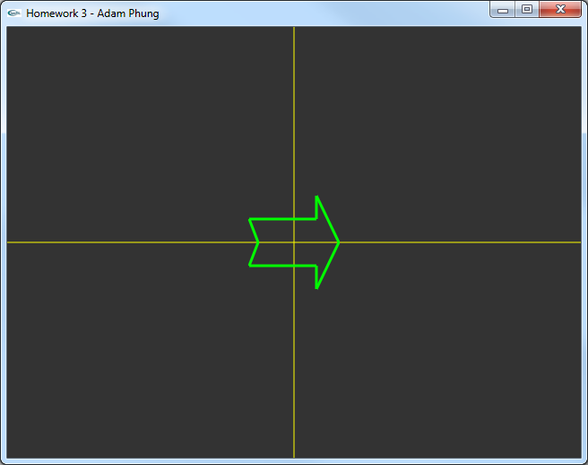

**e) shear your figure along y by a factor of 1.1**

/// Problem e: shear your figure along y by a factor of 1.1

double sheerFactor = 1.1;

a = 1;

b = sheerFactor;

c = 0;

d = 1;

tx = 0;

ty = 0;

for (int i = 0; i < 8; i++) {

Xn[i] = a*shapeX[i] + b*shapeY[i]+tx;

Yn[i] = c*shapeX[i] + d*shapeY[i]+ty;

}

drawShape(Xn, Yn, 8, 3);

